REMEMBERING THE GREAT
CLOUD OF WITNESSES
A SUGGESTED 45-MIN PRAYER GUIDE FOR RACIAL JUSTICE

Below you will find a centring prayer, scripture, story, poetry, an act of commitment and a blessing. Use what you want at your own pace, or follow the suggested timings.
You may need a pen, notebook and Bible.

CENTRING PRAYER [5 min]

Get into a comfortable posture and pray,

‘As I enter prayer now, I pause to be still, slow my breathing, and centre myself in the abiding presence of Christ’

Bring your attention to your breath. Treat each breath in as an arrival. Breathe in God’s presence. As you breath out, imagine letting go of future worries and responsibilities to God. Become present.

Spend 3 minutes in silence. Breathe deeply.

BIBLE READING // HEBREWS 12:1-13 [5 min]

Read slowly, aloud or in your head. You may like to read these verses several times in your preferred Bible translation.

Therefore, since we are surrounded by such a huge crowd of witnesses to the life of faith, let us strip off every weight that slows us down, especially the sin that so easily trips us up. And let us run with endurance the race God has set before us.

We do this by keeping our eyes on Jesus, the champion who initiates and perfects our faith. Because of the joy awaiting him, he endured the cross, disregarding its shame. Now he is seated in the place of honor beside God’s throne. Think of all the hostility he endured from sinful people; then you won’t become weary and give up. After all, you have not yet given your lives in your struggle against sin.

And have you forgotten the encouraging words God spoke to you as his children?
He said,

“My child, don’t make light of the Lord’s discipline,
and don’t give up when he corrects you.
For the Lord disciplines those he loves,
and he punishes each one he accepts as his child.”

As you endure this divine discipline, remember that God is treating you as his own children. Who ever heard of a child who is never disciplined by its father? If God doesn’t discipline you as he does all of his children, it means that you are illegitimate and are not really his children at all. Since we respected our earthly fathers who disciplined us, shouldn’t we submit even more to the discipline of the Father of our spirits, and live forever?

For our earthly fathers disciplined us for a few years, doing the best they knew how. But God’s discipline is always good for us, so that we might share in his holiness. No discipline is enjoyable while it is happening—it’s painful! But afterward there will be a peaceful harvest of right living for those who are trained in this way.

So take a new grip with your tired hands and strengthen your weak knees. Mark out a straight path for your feet so that those who are weak and lame will not fall but become strong. – NRSV

SAINTS OF GOD [5 min]

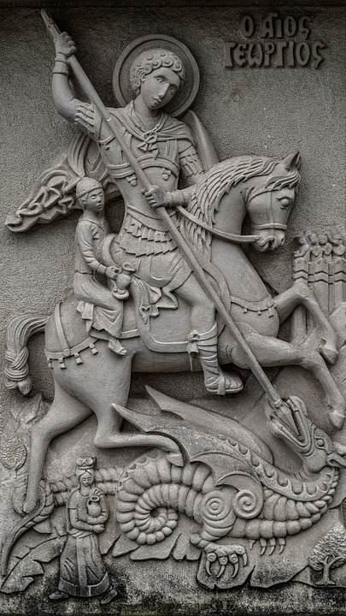
Read the story of St George of England and take a few moments gazing at this image of him.

What do you notice?
What do you know about St George?

Despite being the patron Saint of England, St George was a Palestinian born to Christian parents in Turkey around AD 207. Several myths and traditions surrounding St George have emerged over the last 17 centuries, including the celebrating of him as a symbol of narrow English nationalism, but it is difficult to ensure the factual accuracy of these myths.

What is clear, however, is that St George’s multicultural background and steadfast, public defence of his Christian faith, causing him to be revered by many countries across Europe and the middle East, by Christians and Muslims alike. George was tortured and decapitates on April 23rd 303 in what is now known as Lod in Israel for refusing to deny his beliefs.

‘This Palestinian saint, both mythical and multicultural, can and should be an icon of the new Englishness that embraces cultural and religious diversity. St George today should serve as a warning against narrow nationalism and blinkered patriotism’

- John Perumbalath, Every Tribe by Sharon Prentis.

Through St George, we remember the diverse cloud of witnesses, made up of individuals from all countries, nationalities and ethnicities who have gone before us in faith.

A GREAT CLOUD OF WITNESSES [15 min]

Remember those who you know, who have worked and are working for racial justice and reconciliation. Write their names in the clouds. Pray for them by name. Cheer them on!

AN ACT OF COMMITMENT TO THE WORK OF RACIAL JUSTICE

Read the prayer-poem aloud or in your head. Ask and answer the questions. Make the commitments. Take your time. Do not rush. Be brutally honest with yourself.

We take…

We take inspiration from the great cloud,
Witnessing the courage of those who have gone before us.
Courageous people, like St George, who took the risk of
Standing up and speaking out against injustice.

We take up the baton and choose to run the risk,
Standing on the shoulders of giants, we join the shout.
Losing ourselves, as we fix our eyes on Jesus,
We find the image of Christ in one another.

We take a knee, in prayerful protest,
No longer content, to sit silently on the sidelines.
Today, we join the fight, in confession and commitment,
To the work of antiracism and reconciliation.

An act of commitment:

As you read and answer these questions, you may like to take up a posture of promise and openness (hands open, kneeling or hand on the heart). Your choice.

Q: Do you affirm the inherent worth and dignity of every person?
A: I do

Q: Do you support justice, equity, and compassion in human relations?
A: I do

Q: Do you affirm that white privilege is unfair and harmful to those who have it and to those who do not?
A: I do

Q: Do you affirm that white privilege and the culture of white supremacy, which infest our nation and church, must be dismantled?
A: I do

Therefore, from this day forward,

Q: Will you strive to understand more deeply the injustice and suffering white privilege and white supremacy cause?
A: I will

Q: Will you commit to help transform your church culture to one that is actively engaged in seeking racial justice and equity for everyone?
A: I will

Q: Will you make a greater effort to treat all people with the same respect you expect to receive?
A: I will

Q: Will you commit to developing the courage to live your beliefs and values of racial justice and equality?
A: I will

Q: Will you strive daily to eliminate racial prejudice from your thoughts and actions so that you can better promote the racial justice efforts?
A: I will

Q: Will you renew and honour this pledge daily, knowing that our church, our community, our nation, and our world will be better places because of my efforts?
A: I will

- Racial Equity Pledge questions, by First Unitarian Church of Dallas, Texas revised by SFX & Jonathan Wilson-Hartgrove. Found via @hodeghillvicar on Twitter

STILLNESS [3 min]

Take a few moments in silence. Be still. Breathe deeply. Know God is with you.

TAKE ACTION

Commit to take concrete action in the coming days. Fill in the blank.

You may like to commit to reading a book about Racial Justice, or listening to a podcast, or choosing to follow a diversity of voices on your social media feed. You may like to commit to having an intentional conversation with someone, or to contact one of the people you wrote the name of in the clouds. Alternatively, it might be something else…

This week I commit to _________________________________________________________

_____________________________________________________________________. Amen.

BLESSING [2 min]

