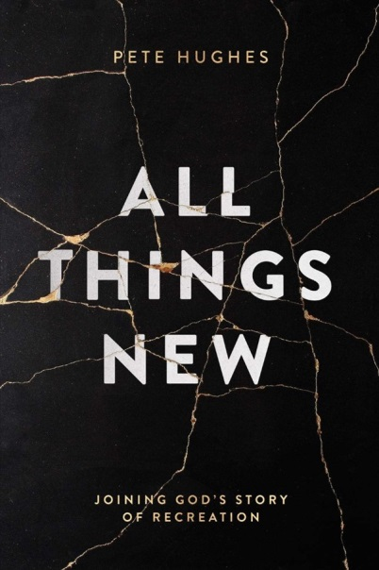

**Lockdown 1. ‘All things New’, joining God’s story of recreation, Pete Hughes £11.99 publisher David Cook.**

Pete, an ordained Anglican minister, was captivated by words of his ordination service to: ‘proclaim afresh in each generation’ the greatest story ever told. Working through all of scripture, he expounds the amazing breadth of that story- not just saving souls, but the healing of nations, the reviving of culture and bringing God’s kingdom to bear in the renewal of all creation. The invitation then for us, helped by regular chapters of personal reflections on his work in King’s Cross London, is to find our place in this great story and join God’s mission to make all things new.

John Mark Comer author of; ‘The Ruthless Elimination of Hurry says: “I simply can’t recommend this book enough. I want every person in my church to read this”

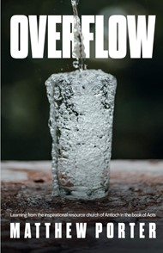

**Lockdown 2 Overflow. Matthew Porter £9.99 Authentic**

Matthew takes as his modal the inspirational resource church of Antioch, in the book of Acts. This book is for anyone who wants to see their church have an overflowing impact on their surroundings, seeing the church renewed and society transformed.

**Lockdown 3 Soulful Nature A Spiritual Field Guide £14.99 cpn**

A series of 12 outdoor retreats/walks over the course of a year with botanist Howard Green and spiritual writer Brian Draper. They encourage us to notice more of our surroundings, engage with them and gain a deeper sense of connection with the natural world.

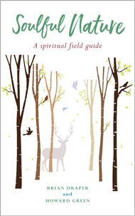

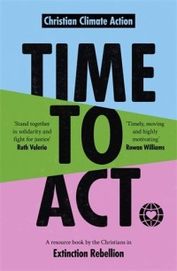

**Lockdown 4 Time to Act. A resource book by the Christians in Extinction Rebellion.** A collection of really readable short chapters on: Christian non-violent direct action for the climate. It is divided into three sections: The Head: accessible theological/ethical reflections. The Heart: deals with the experience and emotions of the climate emergency. The Hands-: practical advice and resources.

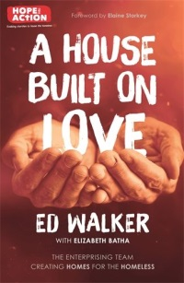

**Lockdown 5 A House built on Love. Ed Walker £9.99 SPCK**

The inspiring story behind the charity ‘Hope into Action’, which in conjunction with churches provides physical ‘Homes for the Homeless’ plus the love, care and nurture of a local church.

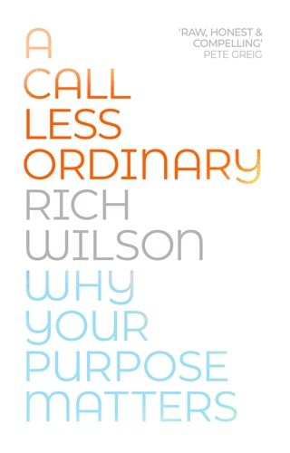

**Lockdown 6 A Call less Ordinary. Why your purpose matters Rich Wilson £14.99 Hodder**

Part of senior leadership team of Open Heaven church in Loughborough and leader of the Fusion movement which exists to see students find hope in Jesus and a home in the local church.

A gripping book, principles for discipleship and following God ,flow naturally out of this story of his life in which he faces really significant personal challenges including the death of their baby son.

**Lockdown 7 Café Theology, Michael Lloyd £14.99 Hodder**

A very readable look at the key doctrines of the Christian faith; quoting, as he does, from films and books as well as theologians. Endorsed by Nicky Gumble, this would be an excellent grounding for those coming through alpha as well as those wanting to revisit what they believe.

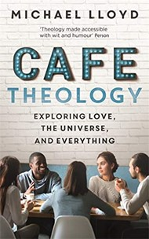

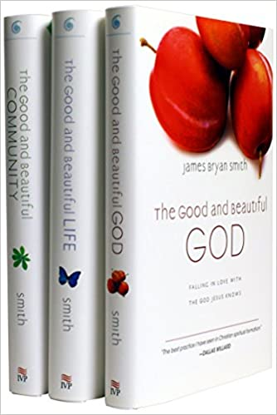

**Lockdown 8 James Bryan Smith The Good and Beautiful God, The Good and Beautful Life and The Good and Beautiful Community, £9.99 Hodder**

James Bryan Smith believes the gospel is about change in our lives today, not just our eternal destiny. In The Good and Beautiful Series he aims to help Christians develop a robust discipleship by helping them understand who God is, what it means to be a Christian and what it means to live in community as a part of God's kingdom. This he does by exposing our false narratives and introducing spiritual exercises to help replace these with the truth.

**Lockdown** **9 How God became king, Tom Wright £12.99 SPCK**

Have you been brought up thinking the good news is just about deliverance from personal sin and a home in heaven after you die? Tom Wright gets you to think again. The Gospel is about Jesus the Jewish Messiah bringing in God’s kingdom rule. Prepare to have your thinking challenged and expanded.

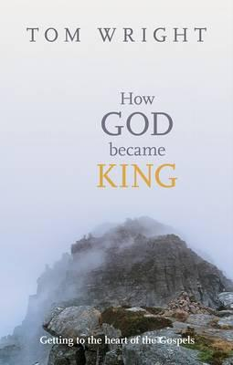

**Lockdown 10 The New Testament in its World**

**An Introduction to the History, Literature and Theology of the First Christians**

**By NT Wright, Michael F Bird £40.00 SPCK**

An introduction to: the history, literature and theology of the first Christians. It is a thorough overview of the New Testament for students, church leaders, and everyday Christians.

Yes I really did read it all. For each book or letter you get an introduction, the Contextual and critical matters, the argument and its place in the big picture. It also looks at the making of the New Testament; textual criticism, canonization and how to live it today.

