The relief road will run to the north and east of Melton, beginning at the A606 Nottingham Road to the north, before rejoining the A606 Burton Road to the south of the town.

According to the county council, advanced work is due to start on the road in January, and will continue until late March.

The main construction of the road is likely to take 26 months and will begin in March, the council said, subject to Department for Transport (DfT) approval of the full business case.

['Missing' masterplan could delay part of Melton bypass - Leicestershire Live (leicestermercury.co.uk)](https://www.leicestermercury.co.uk/news/local-news/missing-masterplan-could-delay-part-3990142)

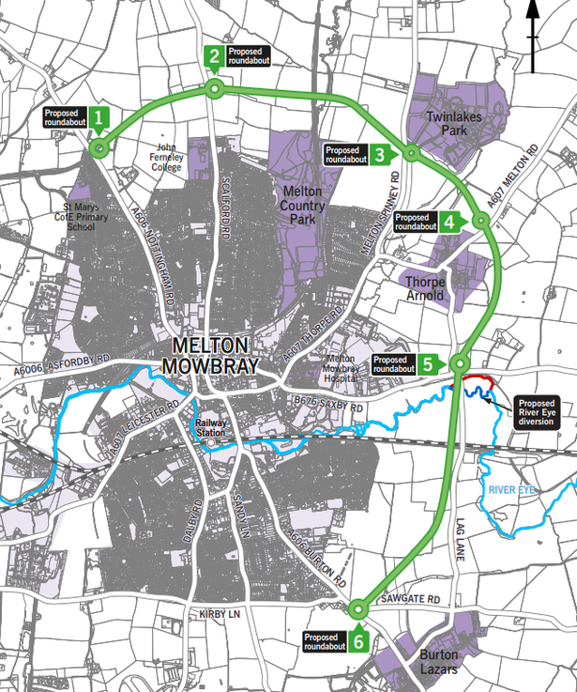

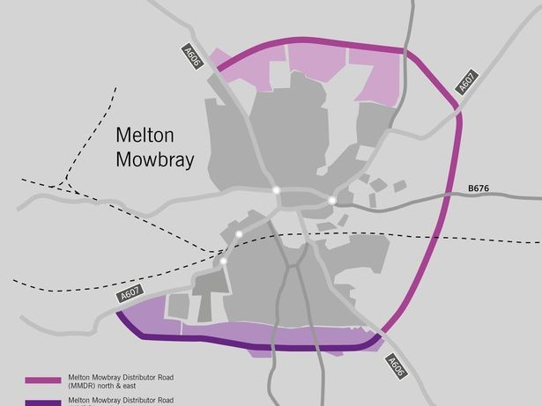

[Melton Mowbray bypass to still go-ahead after costs double to £127m | Construction Enquirer News](https://www.constructionenquirer.com/2022/11/15/melton-mowbray-bypass-to-still-go-ahead-after-costs-double-to-127m/)