New Beginnings

A Service of Welcome,
and Commitment to Shared Ministry

Revd Canon Jonathan Dowman
Growing Faith Enabler
and Associate Priest
Launde Deanery

Friday 29th April 2022
St Thomas a Becket Church, Tugby at 3.45pm

About the Growing Faith role
‘The Growing Faith Adventure is a call for the renewal of hearts and minds so that it becomes second nature to include and value children, young people and households in every aspect of church life for the lifelong formation of faith in the whole of life.’
Growing Faith promotes a partnership between the three communities of Church, School and Household to enable the discovery, exploration and growth for all in those communities. The partnership is imagined as intersections of a set of overlapping spheres to find and promote ways to help faith to grow with children, young people and households.
https://www.churchofengland.org/about/renewal-reform/growing-faith

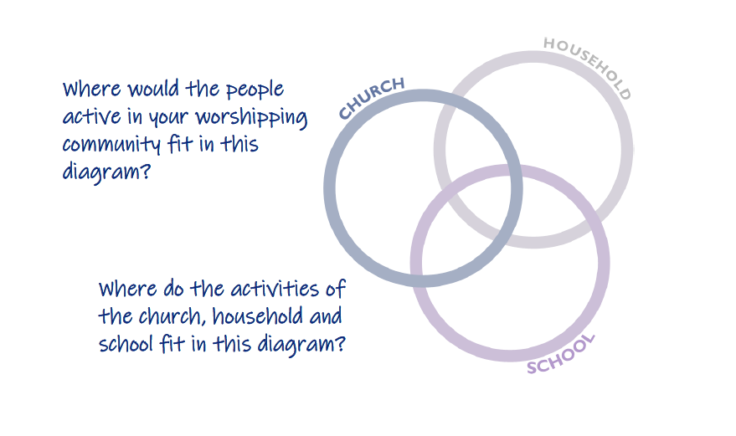

Gathering & Preparation

The Revd Alan Humphrey, Co-Area Dean of Launde Deanery with Jonathan, welcomes people and the Bishop greets the people.

The congregation is invited to join with the words printed in bold.

Song
Please join in with words on the screen or on the separate sheet

The Collect

The Bishop introduces a period of silent prayer and then says:
Almighty and everlasting God, by whose spirit the whole of the Church is made Holy hear our prayer which we offer for all your faithful people,
that they may serve you in goodness and truth to the glory of your name; through our Lord and Saviour Jesus Christ, who is alive and reigns with you, in the unity of the Holy Spirit, one God, now and forever.
Amen.

The Presentation

A member of one of our Deanery Households.
Bishop Martyn, we present to you Jonathan, to be licensed as Growing Faith Enabler and Associate Priest in Launde Deanery.

The Bishop addresses the congregation:
Will all of you who are gathered here, support and encourage Jonathan in this new ministry, now and in the years to come?
We will.
Will you pray for him even as he prays for you?
We will.
Will you care for Jonathan, helping him to find rest and joy in ministry?
We will.
And as your bishop, I too commit to pray for you and to care for you so that you, and all the people of God in this place, may flourish and grow in the love of God.

Dwelling in the Word

Everyone is invited to listen to the story, read by someone from Billesdon and then Hallaton school.
As we listen twice, what images come to mind and where
do you place yourself in what you hear?

A Story about a Farmer
(Mark 4:1-9)

The next time Jesus taught beside Lake Galilee, a big crowd gathered. It was so large that he had to sit in a boat out on the lake, while the people stood on the shore. He used stories to teach them many things, and this is part of what he taught:

“Now listen! A farmer went out to scatter seed in a field. While the farmer was scattering the seed, some of it fell along the road and was eaten by birds. Other seeds fell on thin, rocky ground and quickly started growing because the soil wasn't very deep. But when the sun came up, the plants were scorched and dried up, because they did not have deep roots. Some other seeds fell where thorns grew up and choked out the plants. So they did not produce any grain. But a few seeds did fall on good soil where the plants grew and produced 30 or 60 or even 100 times as much as was scattered.

Then Jesus said, “If you have ears, pay attention.”

The Licensing

Before the service, in front of +Martyn, Jonathan made the Declaration of Assent and took the Oath of Allegiance and the Oath of Canonical Obedience.

The Bishop addresses Jonathan:
Jonathan, before you receive this share in our pastoral charge will you, before God and this congregation, reaffirm the promises you made when you were ordained and accepted the Priesthood out of love for the Lord Jesus and his Church?
Jonathan: I will.

At your ordination to the priesthood, you took authority to watch over and care for God’s people, to speak God’s forgiveness and bless them in His name, to proclaim the gospel of salvation, and to minister the sacraments of his New Covenant. Will you continue as a faithful steward of the mysteries of God, preaching the gospel of Christ and ministering his holy sacraments?
Jonathan: By the help of God, I will.

The Giving of the Pastoral Charge

The Bishop invites the people to sit and Jonathan to kneel. He then reads the legal document and delivers the document with these words:
Jonathan, receive this license, the care of God’s people, which is both mine and yours, in the name of the Father, and of the Son and of the Holy Spirit. The love of the Father enfold you, the wisdom of the Son enlighten you, the fire of the Spirit kindle you; and the blessing of God Almighty, the Father the Son and the Holy Spirit come down upon you and remain with you always.
Amen.

The Commitment to Ministry in Partnership

The Bishop invites members of the Deanery Schools, Households and Churches to stand with Jonathan.

Bishop: Jonathan, as Growing Faith Enabler and Associate Priest will you work in partnership with the others, exercising servant leadership and putting the needs of others before your own?
Jonathan: By the help of God, I will.

Bishop: Those of you who form the communities of our Deanery Schools, Households and Churches, will you work with Jonathan as a colleague and friend, sharing in leadership and oversight and working together to serve the Deanery?
Deanery: By the help of God, we will.

Bishop: And will you renew your commitment to work together to respond well to the “three key questions” of mission and ministry in this diocese: how are you helping others grow in the depth of their discipleship; how are you growing the numbers of Christian disciples; and how are you loving and serving these communities and the wider world?
Deanery: By the help of God, we will do all in our power to grow in
the depth of our discipleship, to grow the numbers of Christian disciples and to grow in love and service of these communities and the wider world.

The Bishop invites all to stand.

Bishop: People of God in this place, will you share in the work of ministry and service, confident in your own gifts and unique contribution, and open to learning and receiving from others?
By the help of God, we will commit to working together in partnership, seeking the forgiveness of others when we make mistakes, even as we forgive those who wrong us.

Receiving the Signs of Christian Ministry

The four Deanery Schools offer Word Maps representing every community they serve, together with an object that speaks of how God has blessed their school.

The Deanery Churches offer a map and a compass, representing the call for us to work together in mission and ministry and the need to seek God’s vision and direction together.

Water is given by someone from a Deanery Church.
To follow Christ means dying to sin and rising to new life in him. Receive this water for the ministry of transformation and rebirth. Help us in making disciples and baptising them in the name of
the Father, the Son and the Holy Spirit.

Bread and Wine are given by someone from Church Langton School.
We are sustained in our faith through Holy Communion. Receive this bread and wine and join with us to receive strength for daily living, so that we can go out in the power of the Holy Spirit to live and work to God’s praise and glory.

A Bible is given by someone from Tugby School.
Hold before us the story of God's love and mercy, the Gospel of our Saviour Jesus Christ. We invite you all to join with us in proclaiming the Gospel of hope and new life.

Bishop: Jonathan, let these be signs of the ministry, which is both mine and yours, and shared by all the people of God. May we find joy together in the service of Christ.

Prayers of Intercession

Jonathan leads the Prayers of Intercession followed by the Lord’s Prayer:
As our Saviour taught us, so we pray

Our Father in heaven,
hallowed be your name,
your kingdom come,
your will be done,
on earth as in heaven.
Give us today our daily bread.
Forgive us our sins
as we forgive those who sin against us.
Lead us not into temptation
but deliver us from evil.
For the kingdom, the power,
and the glory are yours
now and for ever. Amen.

The Blessing

The Bishop blesses the people.

Song
Please join in with words on the screen or on the separate sheet

The Dismissal

Jonathan: Jesus said, “All authority in heaven and on earth has been given to me. Go therefore and make disciples of all nations, baptising them in the name of the Father and of the Son and of the Holy Spirit, and teaching them to obey everything that I have commanded you.
And remember, I am with you always, to the end of the age.”
This is the Gospel of the Lord. Praise to you, O Christ.

Jonathan throws the doors of the church wide open and dismisses the people with these words:

Go in peace to love and serve the Lord.
In the name of Christ.
Amen.

Thank you for joining with us this afternoon and we hope that you might be able to stay for some refreshments. To hear more about the work of Growing Faith in the Deanery please get in touch, let’s have a chat!

Jonathan Dowman
Mobile: 0747 778 3464
Email: Jonathan.dowman@leicester.cofe.org

Copyright material is included from, Common Worship: Services and Prayers for the Church of England (2000) © The Archbishops’ Council. “Praying Our Farewells” © 1992 The European Province of the Society of St Francis.

