Feedback on three Models of Ministry for the
Shaped By God Together Process

Please take time to look at the video or document that explains the ‘why’ behind the process.

Timeline:

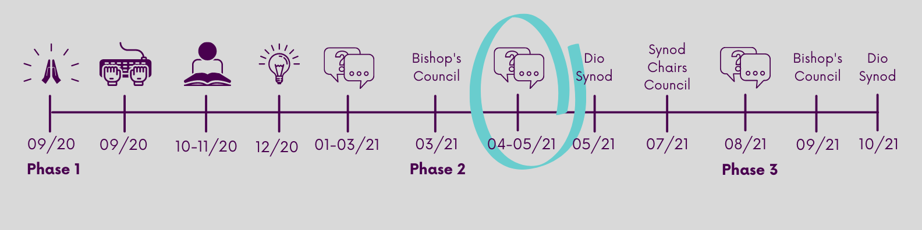
This local conversation and feedback is taking place as part of Phase 2 of the process.
Please complete this feedback form online if possible: https://tinyurl.com/kn86n4va

*You will be asked for your Parish Number when you fill out the form. Your Parish Number can be found here: leicester.anglican.org/about-us/sbgt/pcs.php
- If you are filling this form out as fresh expression of Church please use the Parish Number of the Parish you are associated with. If you are an independent fresh expression please enter 0000.
- If you are an Area Dean holding a conversation for leaders in your deanery please enter 0001.
- If you are filling this out as a benefice please enter each parish number for the parishes you represent.
- We encourage parishes to submit one form where possible, but we will accept multiple forms if necessary. Please make sure you enter the same Parish Number on each form.

Each textbox holds around 150 words.
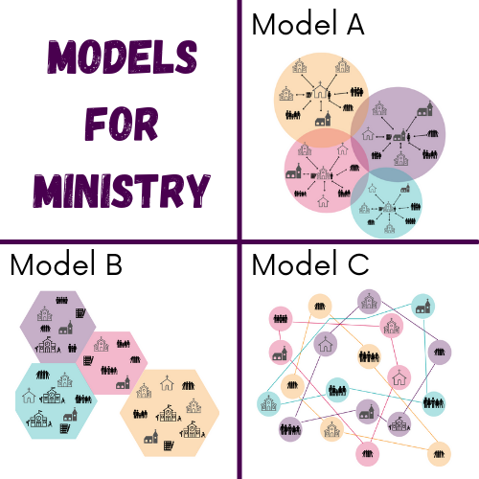
The 3 Key Questions are indicators of how we live out our everyday faith.

- How are you growing, and enabling others to grow in the depth of their discipleship?
- How are you enabling growth in the numbers of disciples?
- How are you serving your community and enabling others to love and serve those around them?

Parish Number(s):

Ministry Model A – Minster

Remembering that our current model of ministry is inadequate and unsustainable, and looking to the future, how well would model A, help us effectively live out the 3 key questions where we are?

0 | 1 | 2 | 3 | 4 | 5 | 6 | 7
I really can’t see it working I can see this working very well
Is there anything that would better help you understand this model?

What would enable you to be more confident about this model?

As a church or fresh expression, what concerns you about this model?

As a church or fresh expression, what excites you about this model?

Ministry Model B – Mission Areas

Remembering that our current model of ministry is inadequate and unsustainable, and looking to the future, how well would model B, help us effectively live out the 3 key questions where we are?

0 | 1 | 2 | 3 | 4 | 5 | 6 | 7
I really can’t see it working I can see this working very well
Is there anything that would better help you understand this model?

What would enable you to be more confident about this model?

As a church or fresh expression, what concerns you about this model?

As a church or fresh expression what excites you about this model?

Ministry Model C – Network

Remembering that our current model of ministry is inadequate and unsustainable, and looking to the future, how well would model C, help us effectively live out the 3 key questions where we are?

0 | 1 | 2 | 3 | 4 | 5 | 6 | 7
I really can’t see it working I can see this working very well
Is there anything that would better help you understand this model?

What would enable you to be more confident about this model?

As a church or fresh expression, what concerns you about this model?

As a church or fresh expression, what excites you about this model?

