Please pray for all those to be ordained, and especially those to be ordained in the Diocese of Leicester this Petertide.

God our Father, Lord of all the world,
through your Son you have called us
into the fellowship of your universal Church:
hear our prayer for all your faithful people
that in their vocation and ministry
each may be an instrument of your love,
and give to your servants soon to be ordained
the needful gifts of grace;
through our Lord and Saviour Jesus Christ,
who is alive and reigns with you,
in the unity of the Holy Spirit,
one God, now and for ever.
Amen.

Pray also for their families, friends and all those who will support them.

Pray for the communities where they will serve their curacy, for their training incumbents and context supervisors.

Pray too for Bishop Martyn who will preside at the ordinations and for The Revd Sue Willetts, DDO in the Diocese of Leicester, who will lead the ordination retreat at Launde Abbey with Bishop Martyn and Anthony Lees-Smith, Diocesan IME Officer.

Pray too for more vocations to all kinds of ministry as we are Shaped By God Together.

What is God’s plan for you?
https://www.churchofengland.org/life-events/vocations

Ordinations 2024
Prayer Card

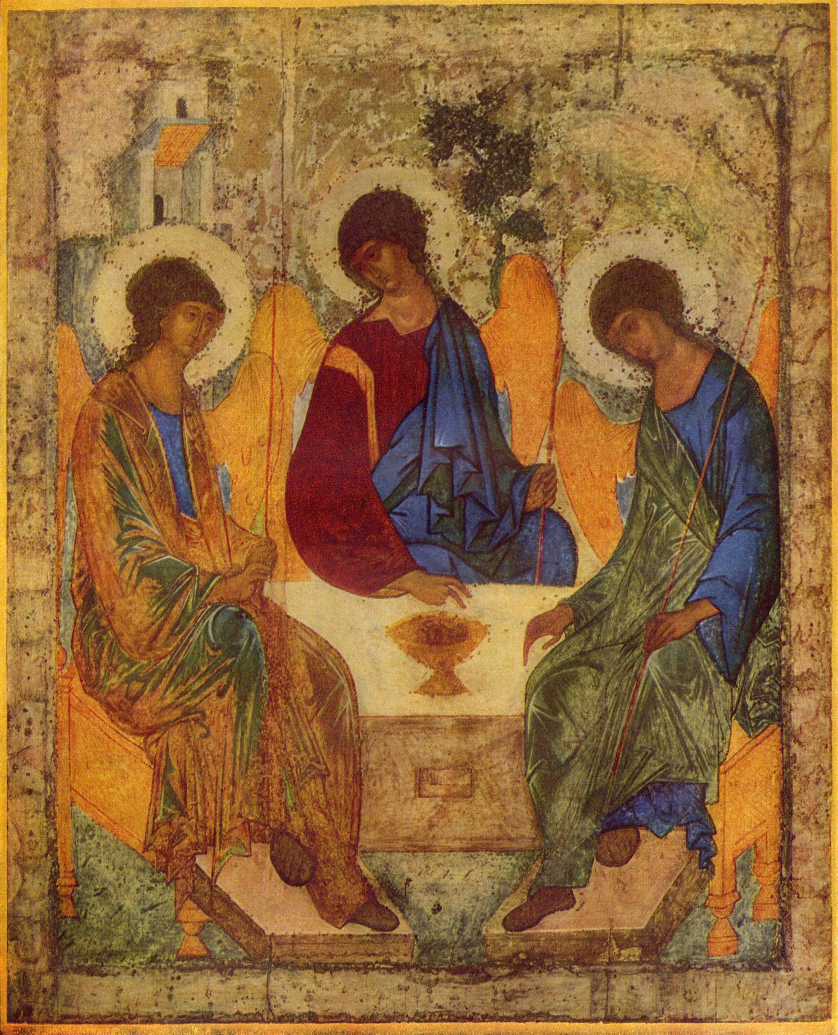

To be ordained Priest
on Saturday 29th June 2024

Cecilia Adjadje Knighton

Bob Edge The Benefice of Barrow-upon-Soar with Walton le Wolds, Wymeswold and Prestwold with Hoton

Linda Harwood The Oadby Great Glen Team
Ministry

Geoff Pinnington Coalville with Bardon Hill and Ravenstone

Dave Rollett Ordained Pioneer Minister in the
Akeley East Deanery

To be ordained Deacon
on Sunday 30th June 2024

Rachael Brind-Surch Birstall & Wanlip

Heather Hall Goscote Deanery

Nicholas Henwood Holy Apostles, Leicester

Stuart Voce Stocking Farm and Beaumont Leys

Cameron Wiltshire-Plant Four Saints

